**Assignment 3 – Potential outcomes and OLS**

**Due date: Thursday, June 11th, 2020 by 5:00pm**

**DIRECTIONS**: The following assignment covers three core parts of the course: potential outcomes, regression and DAGs. Each question is worth 1 point. If you write anything incorrect, you will have points taken off, so be sure that whatever you say it is correct.

**Potential outcomes**

1. Consider the simple hypothetical example in Table 1. This example involves eleven patients each of whom is infected with coronavirus. There are two treatments: ventilators (Y1) and bedrest (Y0). Table 1 displays each patient’s potential outcomes in terms of years of post-treatment survival under each treatment. Larger outcome values correspond to better health outcomes.

Table 1: Perfect doctor example

|  |  |  |  |  |  |  |
| --- | --- | --- | --- | --- | --- | --- |
| **Patient** | **Y1** | **Y0** | **Age** | **TE** | **D** | **Y** |
| 1 | 1 | 10 | 29 | -9 | 0 | 10 |
| 2 | 1 | 5 | 35 | -4 | 0 | 5 |
| 3 | 1 | 4 | 19 | -3 | 0 | 4 |
| 4 | 5 | 6 | 45 | -1 | 0 | 6 |
| 5 | 5 | 1 | 65 | 4 | 1 | 5 |
| 6 | 6 | 7 | 50 | -1 | 0 | 7 |
| 7 | 7 | 8 | 77 | -1 | 0 | 8 |
| 8 | 7 | 10 | 18 | -3 | 0 | 10 |
| 9 | 8 | 2 | 85 | 6 | 1 | 8 |
| 10 | 9 | 6 | 96 | 3 | 1 | 9 |
| 11 | 10 | 7 | 77 | 3 | 1 | 10 |

1. Provide an example of how SUTVA might be violated for treatments of covid-19.

SUTVA can be violated multiple ways for Covid-19 treatments. For example, it is easy to see the homogeneous dose assumption does not hold in real life because the quality and the likelihood that a patient will receive a ventilator is correlated with their wealth. Since different quality levels in the treatment may affect the potential outcomes, the homogeneous doses assumptions cannot be said to be an accurate description of reality. Another way SUTVA is routinely violated is in its Partial Equilibrium assumption. Government are finding that scaling up the availability of treatments is very expensive because every country is trying to stock up on ventilators. That limits the applicability of the potential outcomes model because governments may resort to use lower quality ventilators to meet demand, and thus violate the homogeneous dose assumption. Finally, because of Covid-19 infectious nature, it is clear that there are externalities affecting the potential outcomes of individuals. When an individual receives ventilator treatment, they are no longer infecting other people on the street, so the potential outcome of not receiving treatment is affected by the degree to which sick people receive treatment.

1. Calculate each unit’s treatment effect (TE). (Done in the table)
2. What is the average treatment effect for ventilators compared to bedrest? Which type of intervention is more effective on average?

The average treatment effect of ventilators (ATE) (assuming it is D=1) is -0.54 years. That means that on average, ventilators are detrimental to life expectancy when compared to bed rest (assuming bed rest is D=0). That means on average, the bed rest treatment is more efficient.

1. Suppose the “perfect doctor” knows each patient’s potential outcomes and as a result chooses the best treatment for each patient. If she assigns each patient to the treatment more beneficial for that patient, which patients will receive ventilators and which will receive bedrest? Fill in the remaining missing columns based on what the perfect doctor chooses. (Done in the table)
2. Calculate the simple difference in outcomes. How similar is it to the ATE?

SDO = 0.85 years

The simple difference in outcomes is substantially different form the ATE; they have opposite signs and the magnitude of the SDO is nearly double that of the ATE.

1. Calculate the ATT and the ATU. How similar are each of these to the SDO? How similar are each of these to the ATE?

ATT= 4 years. ATU =-3.14 years.

Once again, ATT and ATU are very different from each other, and form ATE and SDO. First, ATT and ATU have much bigger magnitudes than ATE and SDE: more than 4 times as big in absolute values. The difference between each other was to be expected since the treatment is perfectly correlated to the sign of the treatment effect. ATT and SDO share the same sign, while both ATU and ATE are negative.

1. Show that the SDO is numerically equal to the sum of ATE, selection bias and heterogeneous treatment effects bias. You will need to calculate the ATE, selection bias and heterogenous treatment effects bias, combine them in the appropriate way, and show that their sum is equivalent to the SDO.

SDO = ATE + Selection bias+ Heterogeneous Treatment Effect Bias

Selection Bias =

HTE bias =

HTE bias =

SDO calculated directly = 0.85

SDO calculated via identity = -0.54 + (-3.14) + (0.63*7.14) =0.85 q.e.d

Note that Selection bias equals ATU because .

**OLS**

The following two questions ask you to estimate two regressions. Report your results in a “beautiful table” labeled Table 1 with a simple description based on parts (a) and (b). You may use this opportunity to learn outreg2 or estout.[1]

* 1. Create a dataset based on the perfect doctor treatment assignment from part (1). This dataset should *only* contain D, Age and Y. Then estimate the following equation:

Report the coefficient on . Is it equal to ATE, SDO, ATT or ATU?

* 1. Now run the following multivariate regression controlling for age.

Report the coefficient on . Is it equal to ATE, SDO, ATT or ATU? Did controlling for age recover the ATE?

Table 1

=======================================================

Dependent variable:

-----------------------------------

Outcome

(1) (2)

-------------------------------------------------------

Treatment (binary) 0.857 0.014

(1.430) (2.340)

Age 0.020

(0.043)

Constant 7.143*** 6.355**

(0.862) (1.907)

-------------------------------------------------------

Observations 11 11

R2 0.038 0.064

Adjusted R2 -0.068 -0.170

Residual Std. Error 2.282 (df = 9) 2.388 (df = 8)

F Statistic 0.359 (df = 1; 9) 0.274 (df = 2; 8)

=======================================================

Note: *p<0.1; **p<0.05; ***p<0.01

The coefficient for the treatment on the first regression is equal to the SDO. This was to be expected since the OLS estimation of a model with dummy variables as covariates is interpreted as the difference between presenting (D=1) and lacking (D=0) the relevant characteristic. This means the estimator is exactly the simple difference in means, when there are no other control variables.

Controlling for age does not recover the ATE, but it helps cleaning the coefficient for treatment, since it now only contains the variation on D that is not explained by age differences. The reason that controlling for age cannot retrieve the ATE is that we still do not have the counter factual to know the real effect that the treatment would have in every single patient.

As a matter of fact, neither of the models yields significant coefficients, this is due to the low number of observations. Additionally, it seems that age and treatment explain very little of the variation in the outcome, suggesting (wrongly) that there is no causal link between receiving the treatment and the outcome.

* 1. Create a separate table labeled Table 2. This table should have three columns. The first equation is the multivariate regression. The second equation is the auxiliary regression of D onto Age. The third equation regresses Y onto which is the residual from the second equation. Compare the coefficient on D from the first equation to the coefficient on in the third equation. What does this tell you about how to interpret multivariate regressions?

Table 2

===================================================================================

Dependent variable:

-------------------------------------------------------

Outcome Treatment Outcome

(1) (2) (3)

-----------------------------------------------------------------------------------

Treatment (binary) 0.014

(2.340)

Age 0.020 0.014***

(0.043) (0.004)

Residual treatment variance 0.014

(2.280)

Constant 6.355** -0.403 7.455***

(1.907) (0.236) (0.702)

-----------------------------------------------------------------------------------

Observations 11 11 11

R2 0.064 0.591 0.00000

Adjusted R2 -0.170 0.546 -0.111

Residual Std. Error 2.388 (df = 8) 0.340 (df = 9) 2.327 (df = 9)

F Statistic 0.274 (df = 2; 8) 13.004*** (df = 1; 9) 0.004 (df = 1; 9)

===================================================================================

Note: *p<0.1; **p<0.05; ***p<0.01

As expected, the coefficient for treatment is the same in both the first and the third equations. The reason for this is the way multivariate regressions work: according to the regression anatomy theorem, a multivariate regression coefficient is nothing more than the scaled covariance between the residuals of the auxiliary regression, and the dependent variable. In other words, the coefficients capture the particular effect that the variance of treatment has in the variance of output. Particular means that it is not caused by the other covariates (that is why it uses the residuals).

The results help understand the fact that using control variables may render coefficient estimates more accurate, but not correct the problem of causality since adding additional variables (that are not the counter factual) does not create a counter factual.

Note that the tables are not copies from the console in R. Rather, they are the outputs of a function that generates regression tables in SCII format called stargazer. Results are much better for TeX files, so I will use that word processor in the next assignment.

**Directed acyclical graphs**

1. This question is partly based on a 2005 article published in the Journal of Behavioral Medicine that claimed forgiveness improved physical health outcomes.[2]

Assume that we want to estimate the average causal effect of forgiveness (D) on health (Y) using observational data. Figure 1 represents our belief about how forgiveness and health are related both in the sample and outside the sample.

We believe that forgiveness (*D*) causes health (*Y*), but we only have data on patients meeting with psychotherapists for mental health treatment (*patients)*.

Individuals who are more open towards behavioral therapy in the first place (*openness*)become patients (*patients*). We believe these people are also more likely to forgive (*D*).

Wealth is also important because wealth causes people to see a therapist (*patients*) in part because of their higher willingness to pay for future and present health. Wealth also improves health outcomes. Unfortunately wealth is not in your data. Wealth is also associated with insurance coverage, which also causes people see therapists (*patients)* and which affects health outcomes.

And remember – we only have data on patients. Our sample, in other words, consists only of patients.

* 1. Write down all backdoor paths between D and Y. Mark whether they are open or closed.
  2. What identification strategy would allow you to estimate the causal effect of forgiveness on health? Assume you aren’t limited to merely data on patients.
  3. Now assume you only have data on patients. Assume that forgiveness is binary and you calculate the following simple difference in outcomes:

But in this regression, you only use data that you have on patients. Will your estimate of identify the ATE? Why/why not? Your answer should indicate whether this control strategy opened up in any backdoors or closed any backdoors.

Forgiveness sample collision

Figure 1: Forgiveness-health study.

1. Use Figure 2 for the following questions. In all four DAGs (a-d), X is a binary treatment variable and Y is the outcome variable, U and V are unobservable (apologies that they are not dashed lines). S, Z, X and Y are all observable (in your data). For each DAG, answer the following three questions.

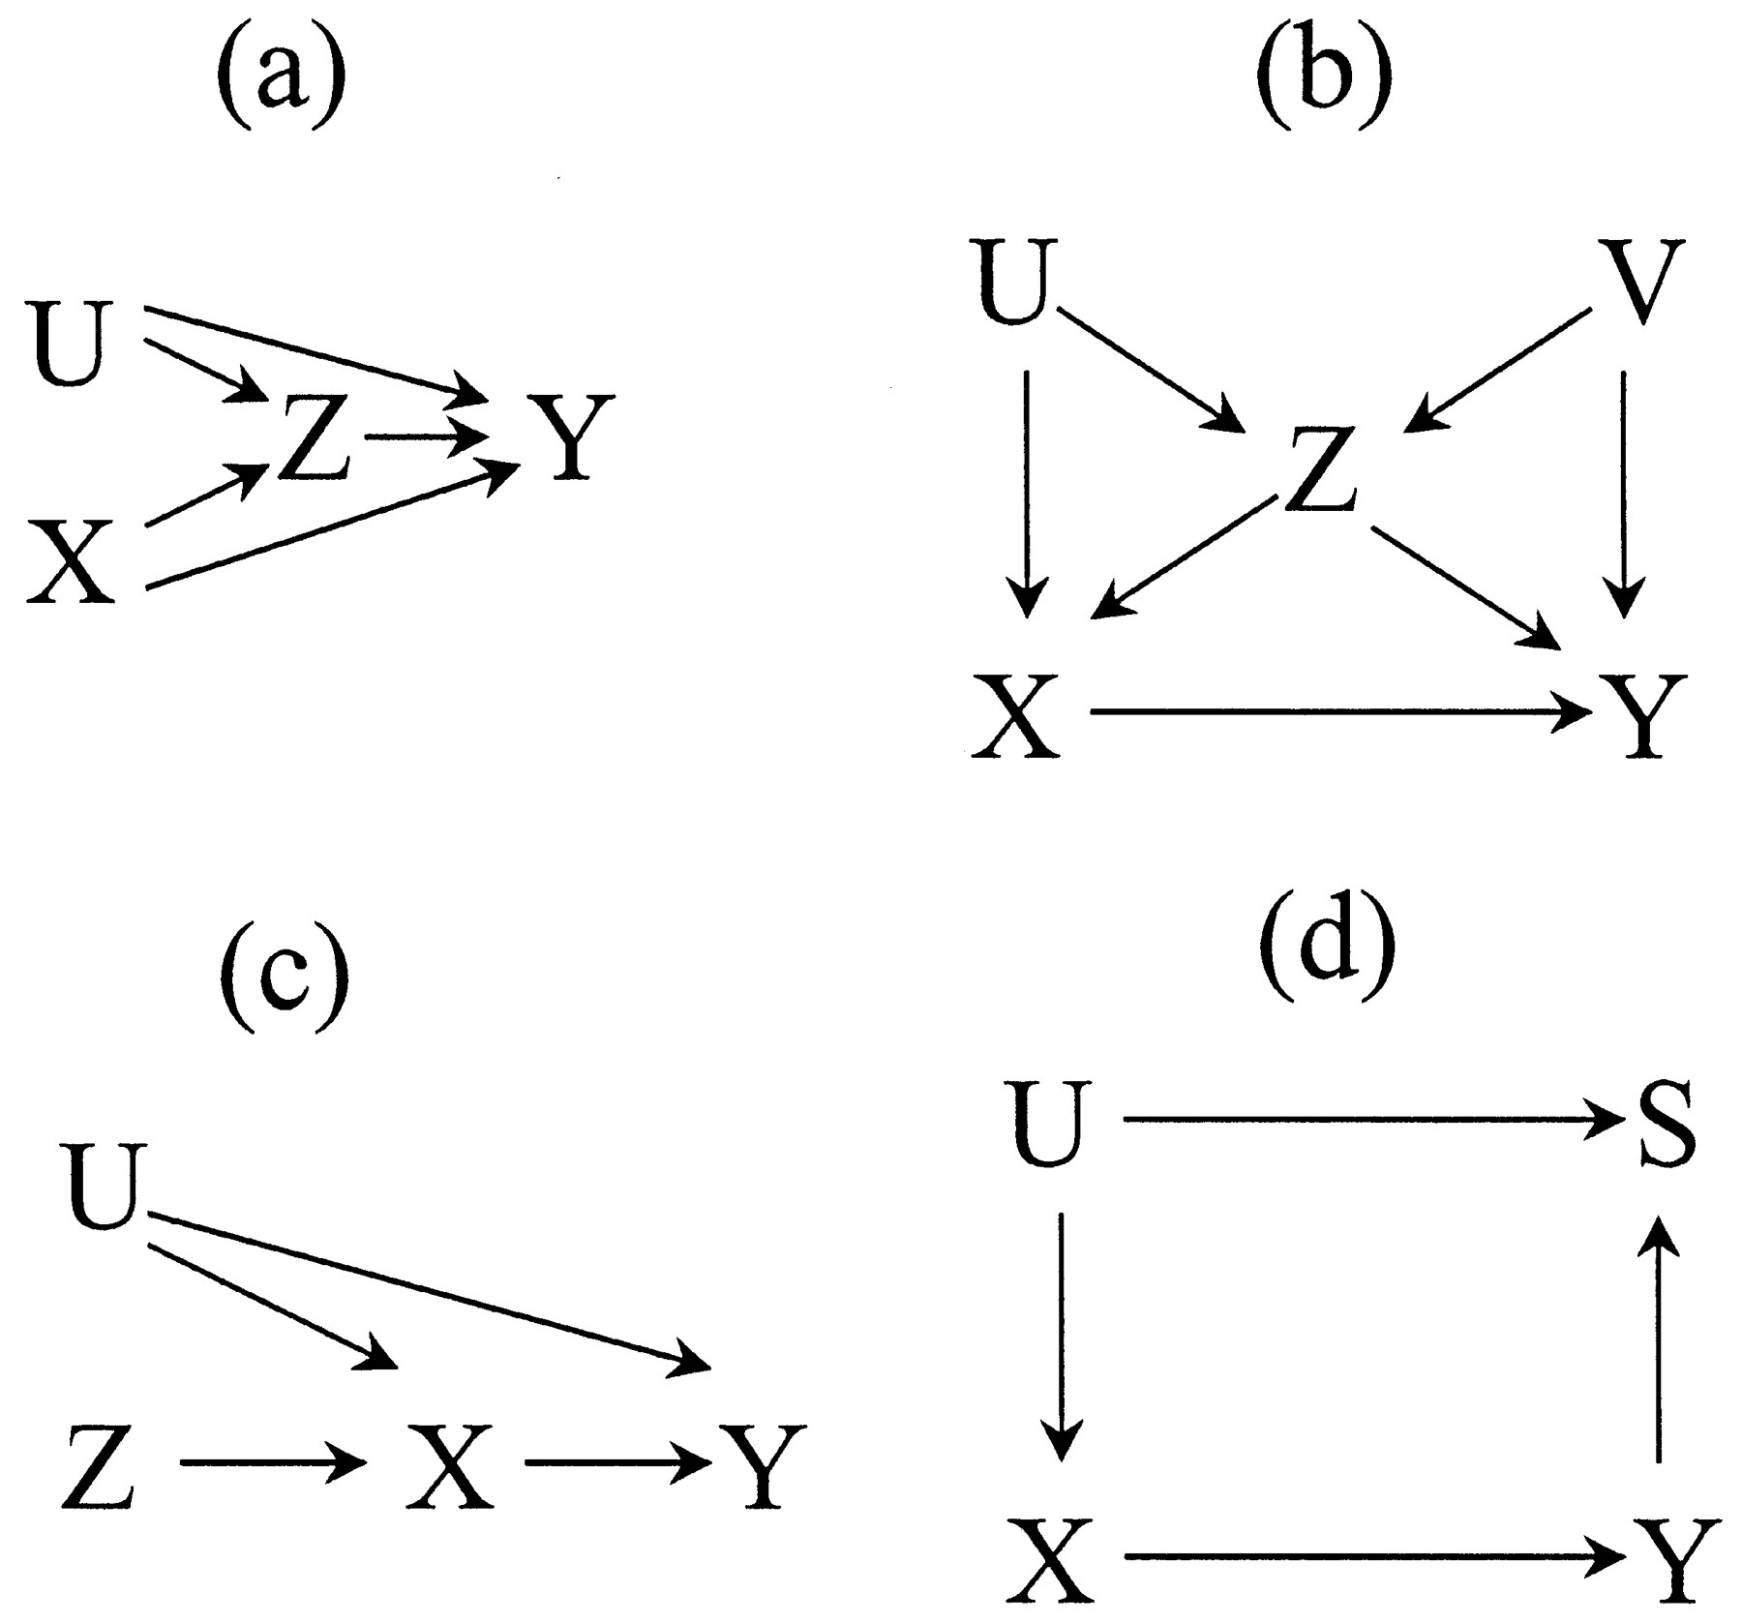

Figure 2: Four DAG examples

* 1. Write down all backdoor paths from X to Y and indicate whether they are open or closed.
  2. Write down a conditioning strategy that satisfies the backdoor criterion. If one does not exist, what is stopping it?

1. I have provided an example for using estout to do this in the /estout subdirectory on github in a file called ols.do, but note that it only creates a LaTeX file. If you want to create something for Word, you will need to use the .rtf format most likely. Read the estout help file online or at Stata.
2. Lawler, et al. (2005), “The Unique Effects of Forgiveness on Health: An Exploration of Pathways”, Journal of Behavioral Medicine, vol. 28 (2) April, pp. 157-167.